Name: ___________________________________________________ Class: __________

2025 TERM ONE MZIMBA NORTH DISTRICT EXAMINATIONS

GEOGRAPHY FORM 4

Subject Number: M073/I
Friday, 12 December, 2025 Time Allowed: 2 h 30 min
(7:30 – 10:00 am)

PAPER I
(100 marks)

MAP READING AND PHYSICAL GEOGRAPHY

Instructions
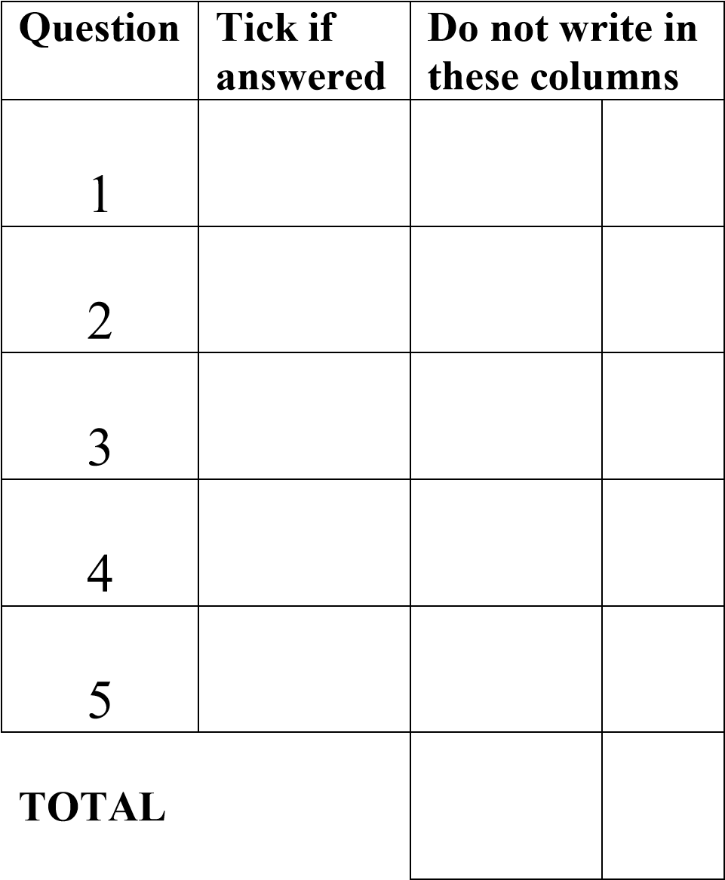
- This paper contains 10 printed pages. Number Please check.

- The paper has five questions.

- There are two sections, A and B. Follow the Instructions for each section carefully.

- Write your Name on top of each page of the question paper.

- In the table provided on this page, tick against the number of the question answered.

- Hand in the question paper to the invigilator when time is called to stop writing.

©MZN-T1-2025
Section A (75 marks)
Answer all the questions in this section in the spaces provided
- Study the 1: 50,000 map extract of Salima, sheet 1333C4 and answer the questions that follow
  - Give a six figure grid reference of the secondary road T375 and main road junction
_______________________________________________________________ (2 marks)
  - (i) State whether Chiwaya in grid 5070 and Midima in grid 5268 are intervisible or not. ________________________________________________________________(1 mark)
(ii) Give a reason for your answer in b. (i) above.
______________________________________________________________
______________________________________________________________ (2 marks)

  - Measure the length of D 146 road shown on the map. Give your answer to the nearest kilometre
_______________________________________________________________ (2marks)
  - Calculate the area found on the eastern side of the railway line.

(5 marks)

(5 marks)

(5 marks)
  - Explain any two land uses shown on the map.
_____________________________________________________________________________________________________________________________________________ (4 marks)

  - Mention any two ways how relief has been presented on the map.
_____________________________________________________________
_______________________________________________________________ (2 marks)
  - Calculate the gradient between the highest point of Nkanga Hill and six figure grid reference 570661. (Take 50ft to equal to 1m)

(7 marks)

- a. Figure 1 shows a plate boundary, use it to answer the questions that follows
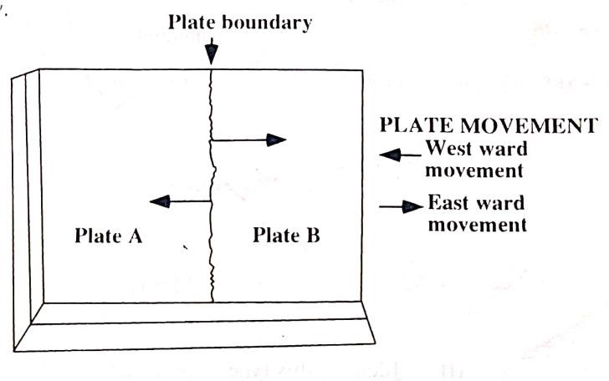

(i) Identify the type of plate boundary.
_______________________________________________________________ (1 mark)
(ii) Mention any three geological features which are likely to be formed along this plate
boundary.
_______________________________________________________________________________________________________________________________________________________________________________________________________________ (3 marks)

(iii) Describe any two negative effects of geological features on the environment.
____________________________________________________________________
____________________________________________________________________
____________________________________________________________________
_______________________________________________________________ (4 marks)
- (i) Explain how sedimentary rocks are chemically formed.
________________________________________________________________________
________________________________________________________________________
_______________________________________________________________ (3 marks)
(ii) Give any two examples of chemically formed sedimentary rocks.
________________________________________________________________
______________________________________________________________ (2 marks)
- Figure 2 is a diagram of a delta. Use it to answer questions that follow
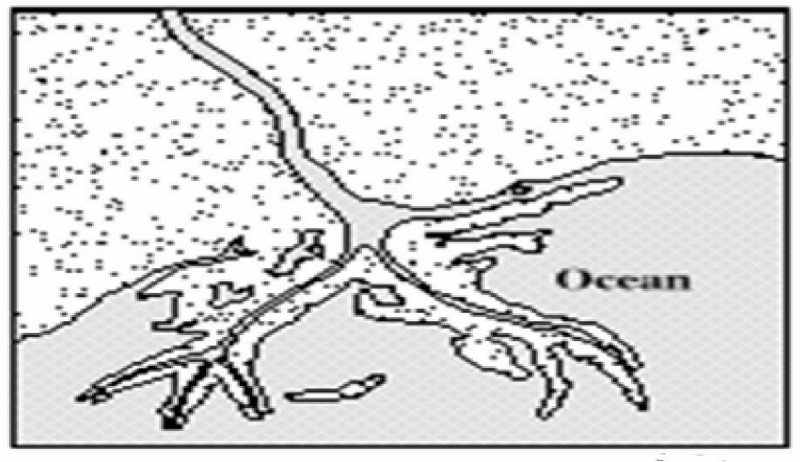
(i). Identify the type of delta above.
________________________________________________________________ (1 mark)
(ii). Describe any three characteristics of this type of a delta.
_______________________________________________________________________________________________________________________________________________________________________________________________________________ (3 marks)

(iii). Explain any two economic values of deltas.
________________________________________________________________________
________________________________________________________________________ _______________________________________________________________________________________________________________________________________________________________________________________________________________ (4 marks)
- (i) Explain two climate change adaptation measures taking place in Malawi.
___________________________________________________________________________________________________________________________________________________________________________________________________________________________________________________________________________________________ (4 marks)
(ii). State any two ways of controlling pollution. _______________________________________________________________________________________________________________________________________________________________________________________________________________________________________________________________________________________________________________ (2 marks)
- a. (i) Draw a globe showing the main pressure belts in the Southern Hemisphere


(4 marks)
(ii). On the globe drawn above, indicate any two prevailing winds in the region they blow.
- marks)
b. (i). Mention any two countries that are affected by the Harmattan winds.
______________________________________________________________________
______________________________________________________________________
(2 marks)
(ii). Figure 3 is a diagram showing the development of local winds. Use it to answer the
questions that follow
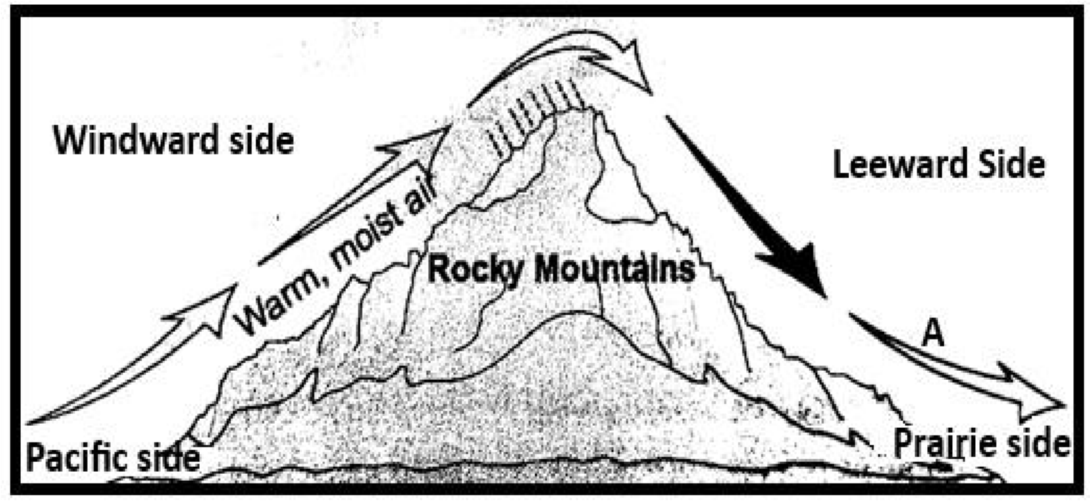
    - Identify the local wind marked A
_______________________________________________________________ (1 mark)
    - Explain any two effects of the local wind shown in the figure 2.
______________________________________________________________________
___________________________________________________________________________________________________________________________________________
_____________________________________________________________ (4 marks)
3. Mention any two characteristics of the wind shown in Figure 2 above.
_____________________________________________________________________________________________________________________________________ (2 marks)

  - (i). Draw a diagram to illustrate the rock cycle.

(4 marks)
(ii). Give any two ways in which rocks are important to the economy of Malawi.
________________________________________________________________________
________________________________________________________________ (2 marks)
d. Differentiate between rain and hail.
_________________________________________________________________________
_________________________________________________________________________
_________________________________________________________________ (2 marks)

Section B (25 marks)
-Answer one question only
- a. Figure 4 shows vegetation of a certain climatic region. Use it to answer the questions that follow.
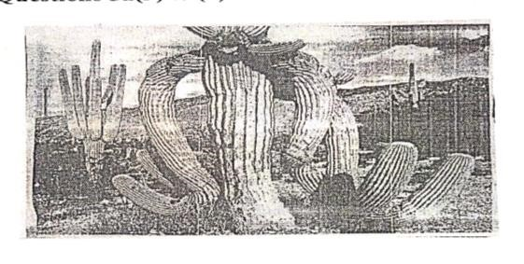
Figure 4
(i) Identify the vegetation in the photograph.
____________________________________________________________________ (1 mark)
(ii) Mention the climate associated with this type of vegetation.
____________________________________________________________________ (1 mark)
(iii) Explain any three ways in which this vegetation adapts to its climatic conditions.
_____________________________________________________________________________
____________________________________________________________________________
_____________________________________________________________________________
______________________________________________________________________________
_____________________________________________________________________ (6 marks)
(iv) Mention any two challenges that prevent agricultural development in the climatic region associated with the vegetation shown above.
___________________________________________________________________________________________________________________________________________________ (2 marks)
- Figure 5 is a pressure map. Use it to answer the questions that follow.
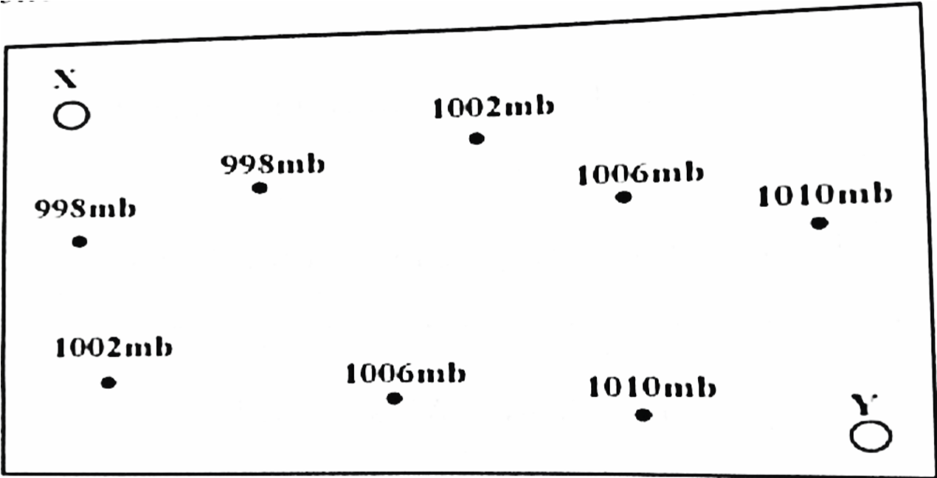
- Draw isobars on the pressure map. (4 marks)
- Using an arrow, to show the direction of wind on the diagram (2 marks)
(iii) Give a reason for such manner of wind direction. _____________________________________________________________________________________________________________________________________________ (2 marks) c. (i) Define the term “air mass.”
____________________________________________________________________________________________________________________________________________________ (1 mark)
(ii) Mention the two ways of classifying air masses.
________________________________________________________________________
_______________________________________________________________ (2 marks)

d. Describe any two characteristics of Inter Tropical Convergence Zone (ITCZ).
______________________________________________________________________________
______________________________________________________________________________
______________________________________________________________________________
_____________________________________________________________________ (4 marks)
5. a. (i) With the aid of a diagram, describe land breeze.
(4 marks) ____________________________________________________________________________________________________________________________________________________________ __________________________________________________________________________________________________________________________________________________________________________________________________________________________________(3 marks)
(ii) Mention any two importance of land breeze to people living in coastal areas.
___________________________________________________________________________________________________________________________________________________________________________________________________________________________________________________________________(2 marks)

- State any one difference between continental air masses and maritime air masses.
_______________________________________________________________________
_______________________________________________________________ (2 marks)
b. Figure 7 is a diagram showing the major air pressure belts on a stationary globe. Use it to answer questions (i), (ii), (iii)
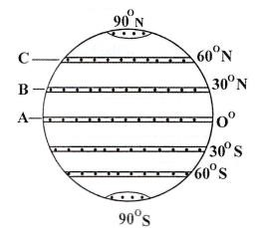

i. Name the pressure belts marked B and C
- _________________________________________________(1 mark)
- _________________________________________________(1 mark)
ii. Explain any two causes of low pressure belt at A ________________________________________________________________________________________________________________________________________________________________________________________(4marks)
iii. Give three characteristics of trade winds. ___________________________________________________________________ ___________________________________________________________________
_____________________________________________________________ (3 marks)

- (i) What is the difference between an environmental issue and an environmental problem
________________________________________________________________________
________________________________________________________________ (2marks)
(ii) Give any three examples of environmental problems ________________________________________________________________________________________________________________________________________ (3marks)
END OF QUESTION PAPER
NB: This paper contains 10 pages.

